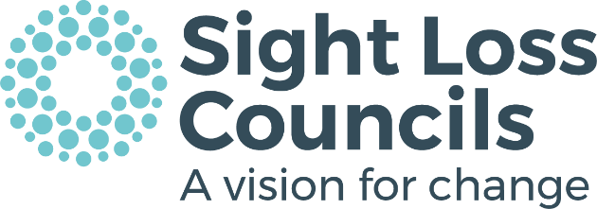

VOLUNTEER ROLE DESCRIPTION
This document describes the main aspects of the volunteer role and any particular skills or experience that will be needed to successfully carry out the role.

TITLE: Sight Loss Council Member
Sight Loss Councils are currently expanding their reach across England to enable people with sight loss the opportunity to influence positive change and improve services at a national and local level.

Each Sight Loss Council aims to make a difference by representing the voice of blind and partially sighted people in the key areas of health, employment, education, transport, and sport.

Main aspects of the role
- To draw from your personal experience as a person with vision impairment, contributing your skills and knowledge to benefit the key aims of the Sight Loss Council.
- To consult and engage with vision impaired people in local communities to identify the key issues and barriers faced specifically in relation to the aims of the Sight Loss Council.
- Attend regular Sight Loss Council meetings to represent the views and experiences of people living with sight loss in your community.
- To make valuable contributions to Sight Loss Council meetings, suggesting and discussing creative solutions and helping to develop clear strategies for influencing and delivering change.
- To establish cooperative relationships with other Sight Loss Council members and organisations, promoting a positive environment for meaningful discussion, information sharing, problem solving and effective planning.
- To represent the Sight Loss Council at various accessibility testing sessions, formal meetings, seminars and forums and contribute to public consultations.

Skills, experience and qualities needed
- You should be a person with sight loss.
- Be able to positively engage with others.
- Demonstrate excellent listening and communication skills.
- Confident in using technology for checking emails etc, or a willingness to learn
- Have the ability to think creatively and solve problems.
- Be able to negotiate, cooperate and influence.
- Be enthusiastic about campaigning and lobbying.
- Show reliability and commitment with good time management skills.

What you will learn and achieve
- An understanding of the issues affecting local people with sight loss.
- A chance to do something positive with the potential to influence change.
- We will provide information and support in public speaking, campaigning and advocacy.
- The opportunity to demonstrate your organisation, communication skills and commitment – which looks great on a CV.

We can provide references for all our committed volunteers after two months or eight episodes of volunteering. We can reimburse essential travel expenses that are agreed in advance.

Date of issue: 17/12/18

END

