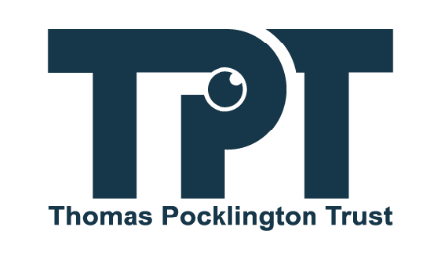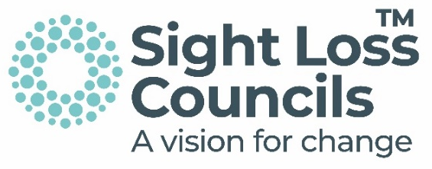

Guidance on overgrown bushes, vegetation and foliage

- Overhanging vegetation can be hedges, trees, shrubs, bushes or other plant types that grow out from within your property boundary onto a footway or carriageway.
- Accessing streets with ease can empower many blind and partially sighted (BPS) people to experience the freedom of independent personal travel and making essential journeys.
- Streets need to be free from clutter, barriers or obstacles, such as overgrown bushes, vegetation and foliage, to allow for safe travel.
- It is important to trim the plants in your garden, so they don't become a hazard or barrier. All pavements should be clear to a height of 2.3 metres (7.5 ft).
- It is essential that lower branches should be at least 2.5m (8 ft) above the footway or carriageway. Hedges, trees, shrubs or bushes should be cut back to your boundary line. There should be a clearway of at least 1m (3ft) around any street furniture (such as streetlamps and road signs) and at least 2m (6ft) above it.
- Reporting to local authorities about hazardous overhanging branches, overgrown hedges and vegetation should be easy and accessible via the local authority channels. Furthermore, regular inspections should be carried out, and where applicable, to issue enforcement notices.

What we know

BPS people constantly tell us about how they have been hurt, injured, and narrowly avoided accidents due to overgrown bushes, overhanging branches, and foliage. Occasionally, people have had to walk onto the road as there isn’t a safe way to continue on the pavement. This may also have implications for vehicle users' sight lines, or it might obstruct street furniture such as street lamps.
This is quite a serious issue, as it can have a detrimental impact on one’s confidence in getting out and about. It also puts blind and partially sighted people and others in dangerous situations, as it may mean that pedestrians are forced to walk into the road. When branches are sharp or wet, they can cause injuries, as they can poke or hit you in the face. Low vegetation that sticks out into the footways and pavements can also create trip hazards, increasing the risk of further trauma.

When surveyed during Listening Month 2022, over 75 per cent of BPS people told us: "Overhanging branches and overgrown hedges and vegetation were a real deterrent to people and a cause of accidents”. In addition to this, despite the Equality Act 2010, streets are inaccessible to disabled people, including people with a vision impairment.
Furthermore, vision-impaired people who have trained to use their white cane are taught to follow the building line/shoreline to navigate safely. Overhanging branches, overgrown hedges and vegetation compromise their training and puts their lives into danger, as they cannot travel safely.
Guide Dog owners are sometimes compromised because there is not enough room for both the owner and their dog to walk on the pavement. This can sometimes lead to confrontation with the public through no fault of their own. Additional challenges are presented when coupled with narrow pavements, where the curb meets a cycleway or a bus bypass border. Other issues arise when a car is parked partially or entirely on the pavement.

There are restrictions, however, as you must not cut or trim a hedge during the nesting season between 1 March and 31 August (inclusive). This is the case unless the overhanging hedge obstructs the passage of, or is a danger to, vehicles, pedestrians or horse riders. Alternatively, if you have received written permission from the Rural Payments Agency (RPA) to do so. This is in cases where the alteration would enhance the environment, improve public or agricultural access, or for reasons relating to livestock or crop production. The cutting and trimming rules do not apply to hedges within the enclosed area of a dwelling or the whole hedge when it marks the boundary of the enclosed area of a dwelling.

All of these situations cause barriers for blind and partially sighted people, people in wheelchairs, parents using buggies, and many others. Whether one is travelling to work, a place of study, a healthcare appointment, or other activity, these experiences are disorienting and stressful, preventing people from safely continuing a journey. Therefore, they don’t promote active travel, mental health, and well-being. In fact, this increases social isolation due to the fear of being unable to access the streets without getting injured.

What we believe

We believe you can massively help blind and partially sighted people in your community. You can do this by trimming back any overgrown branches or shrubs and not obstructing pavements and public footpaths. Public Highways are defined as footways, verges, carriageways, or public rights of way between the boundaries of private property, which could be adopted or unadopted.
Under the Highways Act 1980, Section 154, councils have the power to require landowners to cut back overhanging vegetation. This includes hedges, trees, shrubs, bushes or any other type of plant that grows out in a way that obstructs or endangers highway users.
Plants can quickly become an obstruction on the pavement, so keeping them neat and trimmed throughout the year is helpful. We know that certain local authorities have the following procedure in place. You can report a hazardous obstruction to them, who may then write to the property owner requesting to cut back the obstructing foliage. Once contacted, the householder usually has 14 days to trim the vegetation. If it is not cut back within this time, they will issue an Enforcement Notice. If this is not complied with, they will arrange for their contractor to undertake the work. The cost of this will be charged back to the householder.
The Highways Act 1980 also requires local authorities to maintain those highways which are “adopted” that are maintainable at the public expense (section 41). Secondly, with respect to all highways, to assert and protect the rights of the public to the use of all highways for which they are the highway authority (that is, all except trunk roads). This is to prevent, as far as possible, the stopping up or obstruction of those highways. Furthermore, it is to prevent any unlawful encroachment on any roadside waste composed on a highway (section 130). However, we believe that all local authorities should adopt this procedure as standard practice.

What we do
We support BPS people to campaign locally on accessible streets, including where streets become inaccessible due to low overhanging branches, overgrown bushes, vegetation and foliage. Sight Loss Councils, led by BPS volunteers, are keen to engage with local planners, designers and local authorities to identify solutions and make streets accessible.
- Our national highlights opportunities for local authorities and service providers to improve their delivery of accessible streets. This campaign also includes raising awareness among the general public.
- This national work has extended to issues such as pavement parking, street furniture, and the unchecked rollout of silent e-vehicles and their associated docking.
- SLCs across England campaign locally to reduce overhanging vegetation, working with businesses, local authorities, members of the public and the wider BPS community. They also support national campaigns.
- Form partnerships with other sight loss organisations and stakeholders to drive these objectives forward

References
- Thomas Pocklington Trust - Listening Month Report
- Highways Act 1980
- Hedgerow Cutting

Further information

What is the Equality Act?
Public spaces have a legal obligation to consider and try to remove the barriers disabled visitors might face. This is so they can access and use goods and services in the same way, as far as this is possible, as everyone else. Learn more about the Equality Act 2010 at www.legislation.gov.uk

Accessibility
If you need this document in an alternative format, please email
info@pocklington-trust.org.uk or telephone 020 8995 0880.

About Sight Loss Councils

Sight Loss Councils, funded by Thomas Pocklington Trust, are regional local groups led by blind and partially sighted members. We use the power of lived experience to work with organisations to ensure their work is accessible and inclusive.

Email: info@sightlosscouncils.org.uk
Website: www.sightlosscouncils.org.uk

Publication date: August 2024

