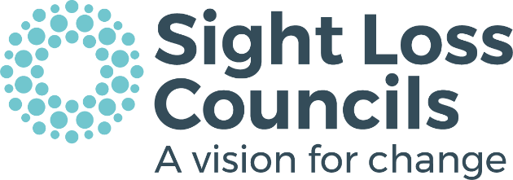
Volunteer Role Description
This document describes the main aspects of the volunteer role and any skills or experience that will be needed to successfully carry out the role.

Sight Loss Council Member
Sight Loss Councils (SLCs’) are currently expanding their reach across England to enable people who are blind or partially sighted the opportunity to influence positive change and improve services at a local, regional and national level.
Each Sight Loss Council aims to make a difference by representing the voice of blind and partially sighted people in the key areas of employment and skills, health and wellbeing and inclusive community.

Main aspects of the Sight Loss Council Member role
- Draw from your personal experience as a blind or partially sighted person, contributing your skills and knowledge to benefit the key aims of the Sight Loss Council.
- Consult and engage with people living, working or studying in your local community to identify the key issues faced by blind or partially sighted people, specifically in relation to the aims of the Sight Loss Council.
- Attend monthly Sight Loss Council meetings and the Annual SLC Conference in October, to represent the views and experiences of blind and partially sighted people in your community.
- Make valuable contributions to Sight Loss Council meetings, suggesting and discussing creative solutions and helping to develop clear strategies for influencing and delivering change.
- Focus on one or more priority projects of the Sight Loss Council as agreed with your Volunteer Manager, providing information, updates, and progress reports.
- Establish cooperative relationships with other Sight Loss Council Members and organisations, promoting a positive environment for meaningful discussion, information sharing, problem-solving and effective planning.
- Represent the Sight Loss Council at various accessibility testing sessions, formal meetings, seminars and forums and contribute to public consultations.
- Contribute to regional and national campaigns – write to members of parliament and local councils, share petitions and personal lived experiences where appropriate.

What skills, experience and qualities are required?
- You must be blind or partially sighted.
- Show reliability and good time management skills and be able to give a minimum of 4 hours per month to the role.
- Be enthusiastic about campaigning and lobbying.
- Be able to positively engage with people and organisations.
- Be able to think creatively and solve problems.
- Demonstrate great listening and communication skills.
- Be confident in using technology or a willingness to learn.
- Be able to negotiate, cooperate and influence.
- A commitment to learn and develop within the role, undertaking relevant training and learning opportunities.

What will you learn and achieve?
- An understanding of the issues affecting blind and partially sighted people at a local, regional, and national level.
- A chance to do something positive with the potential to influence change.
- Access to an excellent core training package with ongoing learning and support.
- The opportunity to work with, and learn from, other blind and partially sighted people at a local, regional and national level.
- The opportunity to demonstrate your skills and expertise– which looks great on a CV.
We can reimburse essential travel expenses which are agreed in advance.
For an informal chat or to request an application form please email, volunteering@pocklington-trust.org.uk or call 020 7031 6376.

