

Top tips for retail staff assisting blind and partially sighted customers in store





The spending power of disabled people and their households amounts to £274 billion per year, and a fifth of your potential customers will have a disability.
Sight Loss Councils, led by blind and partially sighted people, have worked with retailers to produce this useful guide based on lived experience. This is to ensure customers can access your store and to create a positive shopping experience for everyone.

This resource does not claim to have all the answers, but it offers practical tips to enable staff to learn as they go and adapt what they offer to the individual needs of the customer. Throughout this document, the blind and partially sighted (BPS) shopper will be referred to as ‘customer(s)’.

Section one: Spotting sight loss



- There are a few signs that could help you identify a customer who may require assistance. These visual indicators could include the use of a white cane, the wearing of a sunflower badge or lanyard, a customer being guided by an assistance or guide dog, or a customer being guided by another person.
- Some customers carry nothing obvious and may move freely and unaided until they approach staff to request shopping assistance.
- If you notice a customer standing still for a long time, moving cautiously or seeming to walk with no clear aim, approach them saying, ‘Can I help you?’. They may be waiting for someone but might gladly accept your help.
- Remember that customers may have enough vision to spot a uniform, or identify you as staff by some other clue, but still might need help because of sight loss, eg reading small print.
- Customers might be perfectly able to make eye contact or see colour. Remember, if they then ask for help with reading or finding items, sight loss might still be the reason.

Section two: Introductions

- There’s no harm in asking if a customer needs help. Worst case scenario is that they might say no – this is no different from any other customer at this point.
- Say ‘hello, can I help you?’. Introduce yourself as staff. It’s good to do this as soon as you notice the person, even if the customer then must wait a little. By doing this, they at least know that help is coming.
- Ask if and how the customer wants to be guided, as they will know what level of support they need. This could range from just following you closely to letting them take your arm, elbow or shoulder. All are good methods, depending on the individual’s preference.
- As you guide, you don’t need to describe everything you pass. The customer will be far more intent on what they need to buy.

Section three: Just before you get started

- Ask what help the customer needs and what you can do to ensure they find the right items.
- Ask what the customer wants to buy early. This means you can walk to different parts of the shop in the right order to save time.
- Remember the customer might accidentally interrupt this order if they forget something. Browsing can often be challenging as it involves scanning shelves and aisles as you shop.
- Finally, if you have a unique technology or process for locating or ordering, then be clear that you can help with that too.

Section four: While shopping

- Ask the customer to tell you about colour, fashion preferences, or things they must avoid such as nuts. This is their responsibility, but proactive customer service is always best.
- Don’t be shy about using words and descriptive language – conversations about products are hugely helpful.
- Please listen to the customer. If they want smart casual clothes, this information helps you narrow the search. Similarly, if they can manage escalators, believe them.
- Remember the customer may need to touch items. If there is a hygiene concern, you can always put things like fruit in bags so people can be sure they are choosing the right item.
- When searching for something, do your very best to find it. Look a couple of times and, if need be, ask colleagues for help.
- Be discrete – a customer may not want their clothing sizes or contraceptive needs discussed across a shop.
- Feel free to read details on labels – sometimes this is exactly what the customer needs to know.
- Go at the customer’s speed. They might need time to make decisions, or they might be in a hurry. Ask them if you can’t judge it.
- Never assume what the customer needs. Even if you know them, they don’t always want the same items.
- Inform the customer about any offers they may be unaware of. Everyone loves a bargain.
- Try not to talk about the customer as if they are not there. Yes this actually happens, and they will hear you from further away than you might expect.
- Remember, if you offer bookable, dedicated support for people with access needs, the customer may have difficulty accessing this prior to their visit. Where possible, such offers of support should also be there for those just walking by.
- Help for the customer should also not depend on using technology. Many people may struggle with it, whether they can see or not.

Section five: Paying and exiting

- Where possible, offer to queue with the customer. If this is not possible, try your best to explain the procedure. If you offer a designated till service and there is no need to queue, take the customer to it if they require this support.
- Be ready to help with packing. Some people will appreciate having hands free for paying.
- Make sure they can find the card machines – you can guide a person gently by the wrist for tasks like this but it’s wise to ask first if they mind you showing them.
- Tell the customer the total price and when the payment has gone through. They also need to know anything that others can easily see on displays etc.
- Ask where they want to go next. Some will want to exit from where you met them, others might need help to a bus stop or taxi rank. This is reasonable if it’s a short walk, but you may not be covered by insurance to go a long way or cross busy roads.

Section six: One-off changes and reasonable adjustments
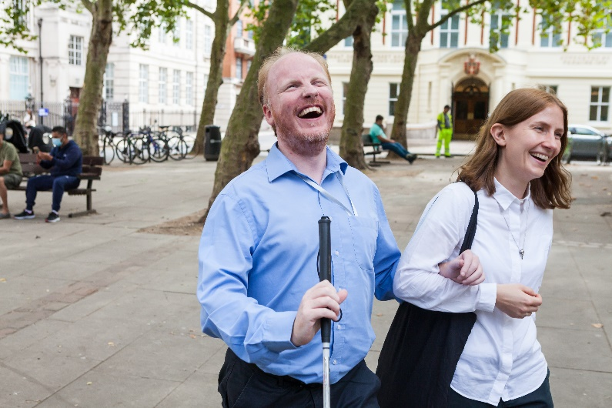

- Level of clutter – walkways should be clear for health and safety reasons. A blind or partially sighted customer can risk hurting themselves.
- Background noise – it is reasonable for music to be turned down, for example, if staff and the customer can’t hear each other.
- Lighting – more lights could be turned on to help a customer navigate, follow a staff member or read packaging themselves.
- If such things are key to your brand or store atmosphere, you can revert once this customer has left. These are good examples of reasonable adjustments if customers struggle with noise or glare.

Section seven: Talking about disability

- Don’t worry about saying, ’having a look at this’ or ‘seeing if you can find that’ – we use these phrases too.
- Do try to avoid broad questions about how they cope with this or that. The customer may not mind, but they aren’t there to educate staff. Such questions are also just hard to answer.
- Avoid phrases like ‘suffering from’ or ‘handicapped’ when talking about disability – both are old-fashioned terms and are widely viewed as negative expressions.
- It’s also best to put the person first eg ‘People with disabilities.’
- Following consultation with the blind and partially sighted community, the preferred term to use is ‘blind and partially sighted’. We may also use the term ‘visually impaired’ to describe any degree of sight loss. We avoid using ‘people living with’ or ‘affected by’ sight loss.
- Remember, you don’t need to discuss disability at all whilst helping someone shop. For many, fear about language is a real issue, but focusing on the task means the subject probably won’t arise.
- If it does, as already stated, just ask what term the person prefers.

Section eight: What is the Equality Act?

Retailers have a legal obligation to consider and try to remove the barriers a customer might face because of a disability. This is so they can access and use goods and services in the same way, as far as this is possible, as someone who’s not disabled. This is set out in the Equality Act 2010.

Accessibility

If you need this document in an alternative format, please email info@pocklington-trust.org.uk or telephone 020 8995 0880. References For advice on physically guiding blind and partially sighted people, visit www.rnib.org.uk Access further detail on the Equality Act 2010 at www.legislation.gov.uk Learn more about common eye conditions at www.pocklington-trust.org.uk/common-eye-conditions

About Sight Loss Councils

Sight Loss Councils are led by blind and partially sighted members. We tackle local issues and work with businesses and service providers to improve the accessibility of their services.

- Email: info@sightlosscouncils.org.uk
- Web: www.sightlosscouncils.org.uk
- Facebook: @SightLossCouncils
- Twitter: @SLCouncils

Publication date: November 2022

