Supporting Blind and Partially Sighted People Through Mass Testing
Below is a summary of some adjustments and considerations which will improve the mass testing experience for blind and partially sighted people.

Talking to a blind or partially sighted person
Ten tips to help you communicate with a person with sight loss who comes to a mass testing venue. The advice given here will help you feel confident about talking to someone with sight loss.
- Gain the person’s attention by speaking
- Introduce yourself and what you do
- Always talk to the person directly, rather than their sighted companion
- Use verbal responses, avoid nods and head shakes
- Verbalise your actions
- Inform people when you are walking away from them or leaving the room
- Remember if someone is blind, it doesn’t always mean they have no sight at all
- In a group conversation, always make it clear who you are and who you are speaking to
- Provide information in an alternative/accessible way - digital, audio, large print or braille
- Ask the person what support they require, if someone usually requires sighted guiding follow the current guidelines

What people providing guiding support to customers can do
Getting support outside of your home establishes the principle that volunteers and staff from organisations such as supermarkets, transport hubs and hospitals can provide sighted guiding support. Staff or volunteers involved should follow their own organisation’s policies and guidance, which should include the mitigation advice set out above in sections 4, 5 and 6.
The organisation providing the support should:
- have already followed guidance for working safely during coronavirus to minimise risks for staff and customers;
- have provided any necessary training and equipment to their staff;
- on the day, check the person being supported hasn’t got COVID-19 symptoms and hasn’t been advised to stay at home or quarantine themselves, before providing support; and
- maintain records of the people who have been supported by each member of staff for 21 days and be prepared to provide this information to NHS Test and Trace, if needed.
In addition, people needing sighted guiding support should:
- where possible, book support in advance;
- set out what support you need;
- be prepared to give your name and contact details; and
- if contacted by NHS Test and Trace, follow their advice.
Current guidelines on sighted guiding vary slightly depending on the specific public health advice in each country.
Sighted guiding (England) - RNIB Guidance (Word)
Sighted guiding (Wales) – Public Health Wales
Social Distancing (Northern Ireland)
Sighted guiding (Scotland) - Scottish Government

Signage to and in the testing venue
An important consideration is the placement of signage. There should be no obstructions placed on pavements and walkways for key routes leading to and from the mass testing venue. Signage should be placed so that it does not cause an obstruction and the use of advertising boards or similar should be avoided.

Printed Material about mass testing
Quick tips based on the minimum standards set by ‘The UK Association for Accessible Formats’ to help make sure your printed material can be read by as many people as possible.
- Standard Print Size - Text should be at least 12 point for clear print but Ideally 14 point. Arial 14 point can be read by over 96% of the population and reduce the need for alternative formats. The RNIB use a minimum 14-point.
- Large Print Size - Text size should be at least 16 point for large print but Ideally a minimum of 18 point.
- Font Style– Fonts should be a simple, legible sans serif font such as Arial, Helvetica or Calibri
- Subscripts - Text such as page numbers and labels should ideally be the same size as the main text
- Contrast – There should be a strong contrast between text and background colours.
- Emphasis - Avoid italics, underlining or large blocks of capital letters
- Visual Representations - Information should not be conveyed solely through colour, images or diagrams
- Alignment – Ensure text is left aligned except in exceptional circumstances
- Spacing – Ensure adequate line spacing and space between paragraphs for ease of reading
- Columns – Avoid columns if possible. If columns are used, there should be adequate space between them and a vertical dividing line
- Paper Size – Use A4 paper unless content or purpose dictates otherwise
- Paper Quality - Paper should be non-glossy and of sufficient weight to avoid show-through
- Enlargement Quality – Do not create enlarged versions of documents using a photocopier (other than exceptional cases)
Further guidance on the production of accessible formats is available from UKAAF's website: www.ukaaf.org

Face coverings, exemptions and social distancing wearables
It is also important that staff are aware that disabled people, including people with sight loss are exempt from wearing a face covering as these can impair their remaining useful vision. They may be carrying a card or badge to show they are exempt, but this is a personal choice and is not required by law. If a person informs a member of staff that they are exempt from wearing a face covering, staff should respect their explanation and allow them to enter.

Disabled people, people with sight loss, older people and people with mobility issues may find social distancing challenging. There are a number of wearable products that people may use to indicate to others that they want to maintain their distance but find it difficult.

Mass testing staff should be aware of these resources and it will be helpful for them to identify a person who may need some additional support.

Please give me space: https://pleasegivemespace.uk/

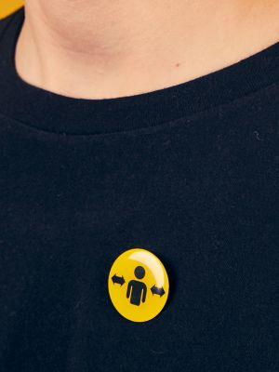
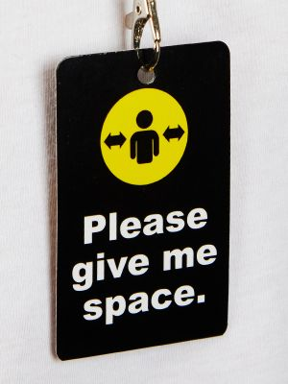
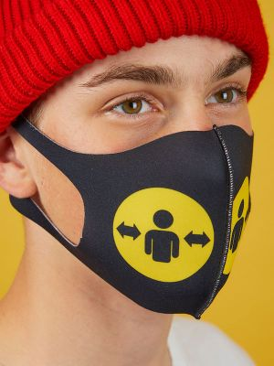
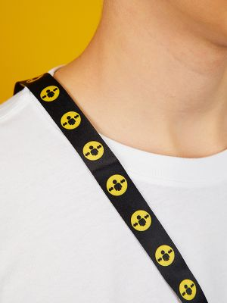

[images show wearable social distancing resources including a badge, lanyard and face covering]

Distance aware: https://www.bevancommission.org/distance-aware

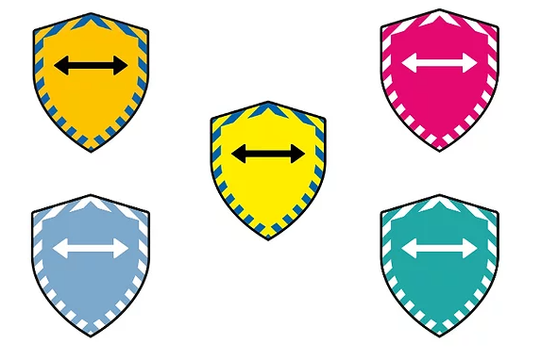

[image shows distance aware social distancing symbols]

Hidden disabilities sunflower: https://hiddendisabilitiesstore.com/

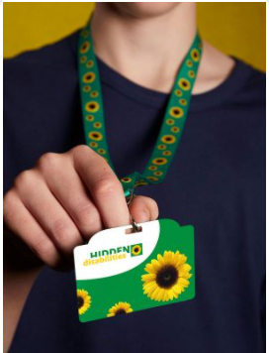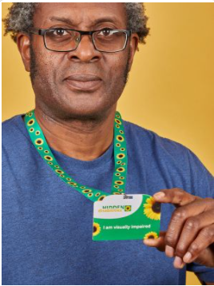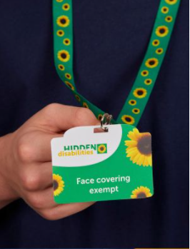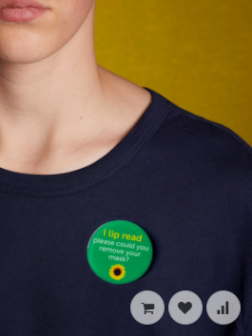

[images show hidden disabilities sunflower lanyards and badges with ‘I am visually impaired, ‘face covering exempt’ and ‘I lip read please could you remove your mask’ instructions]

Other considerations for mass testing venue staff

Lighting
Here is Lighting Guide developed by Thomas Pocklington Trust is designed to assist visually impaired people to improve lighting in their homes, increasing their independence, comfort and safety, but much of the advice is relevant to any settings where a person with a visual impairment may come to. https://www.pocklington-trust.org.uk/wp-content/uploads/2020/10/Lighting-Guide-2018-PDF-1.pdf
Training
RNIB and TPT would be happy to work with Test and Trace on training for staff on sight loss awareness and to produce more specific resources.

Contact:

michael.wordingham@rnib.org.uk

mike.bell@pocklington-trust.org.uk

